KENDRIYA VIDYALAYA OF BHANDARA
Initiative of NEP 2020
NEP 2020 aims at giving new directions and height to education system. At KV OF Bhandara we are committed to implement NEP 2020 in letter and spirit. Some of the initiatives taken to implement NEP 2020 are as under-
- As per directions in the NEP 2020 it is ensured that every year, every teacher participates in at least 50 hours of CPD ( continuous Professional Development) programme. All teachers of the Vidyalaya have undergone training of NISHTA ( National Initiative for School Head and Teachers Holistic Advancement ) NISHTA 1.0 for elementarty teachers, NISHTA 2.0 for secondary level and NISHTA 3.0 for primary teachers under NIPUN Bharat mission. All these training is done through DIKSHA portal. Apart from this teacher are using MOOC (massive open online courses) as per their interest to upgrade their knowledge.

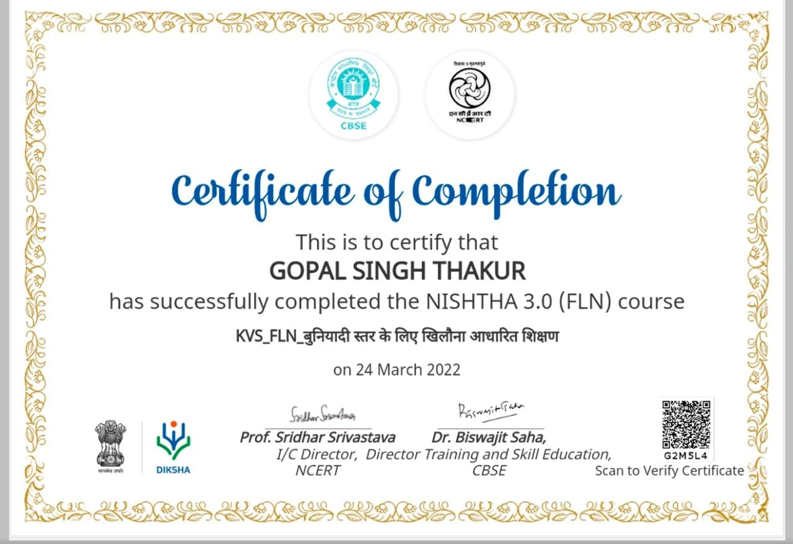

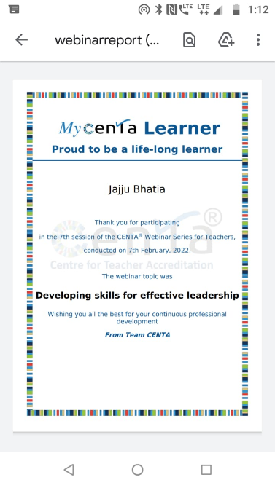

- Under NIPUN BHARAT MISSION all stake holders were made aware of the goals of languages and maths which every child has to achieve by the time he/ she reaches class three.

To improve reading habits of students apps like READ ALONG has been provided to students which helps them to read at their speed in both languages English and Hindi.

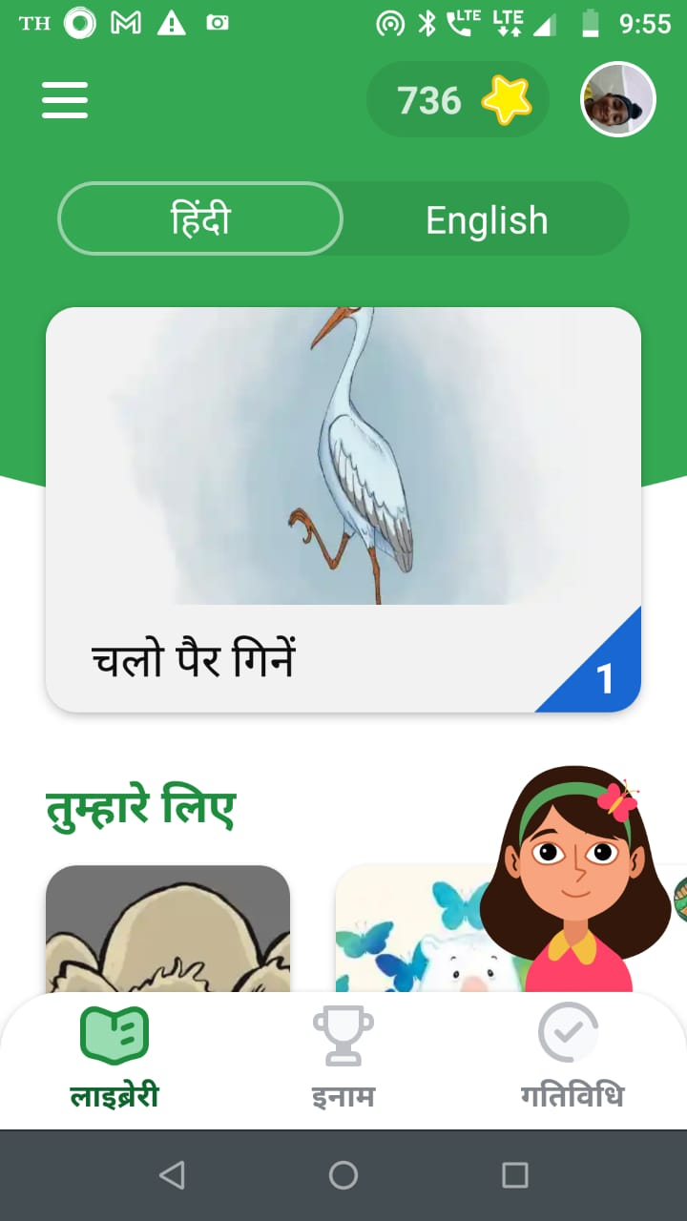

Head Master of the Vidyalaya made a video explaning use of READ ALONG APP and shared it through youtube.
https://youtu.be/CbNnjvRAGZg
- Students are motivated to purchase / share story books and to read them regularly. MAGIC POT a weekly magazine by manorma publication is now very popular among kids and a large number of students have subscribed it online. This is providing quality reading material to students.
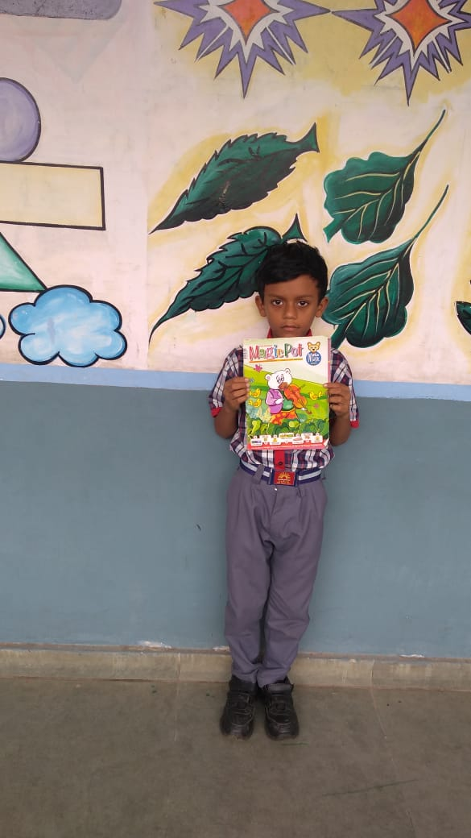

- Co-operative library has been set up in all classes where students on occasion of their birthday contribute a book for co-operative class library and read it whenever possible.

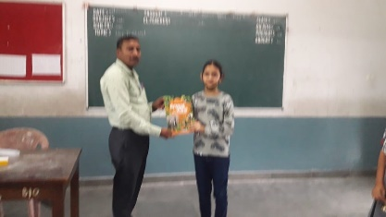

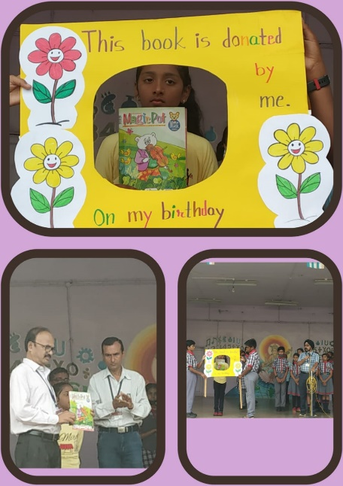
- Reading corners have been set up at various points where news paper and books are available freely and can be read by students.
- FLN is being implemented in mission mode. Teachers have attended training programmes at regional and Vidyalaya level. Students of class 1 and 2 are motivated to set up FLN corners in their home which display alphabets, varnmala and basic words. A FLN corner is also developed in primary resource room.
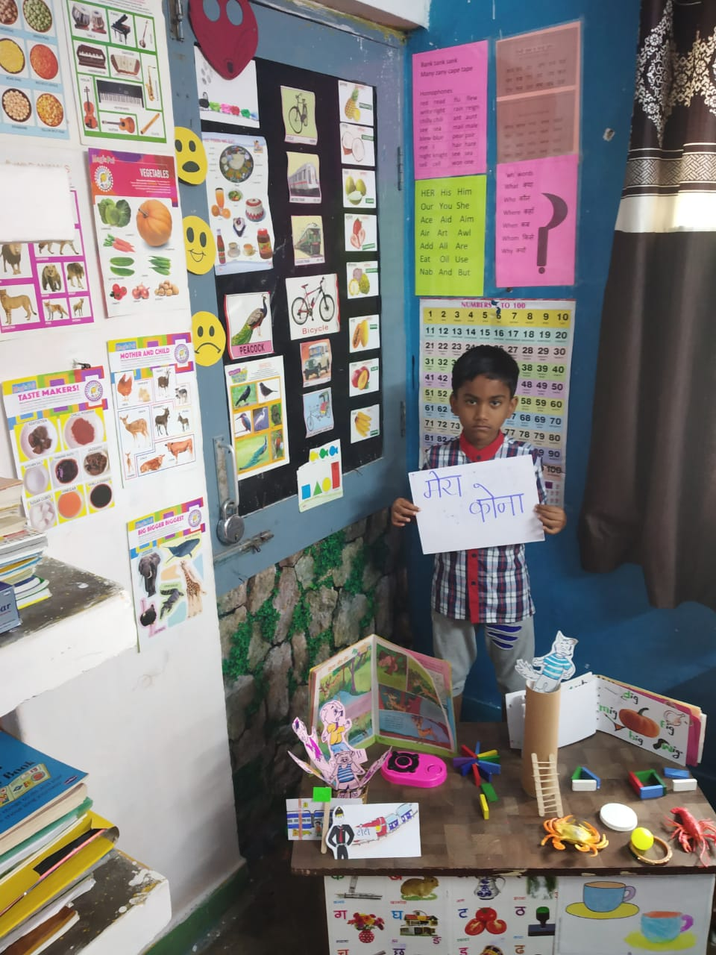

- Experiential learning is given importance and simple tasks like making lemonade are done by students. Hands on experiment are given importance. Students are given opportunity to germinate seeds.

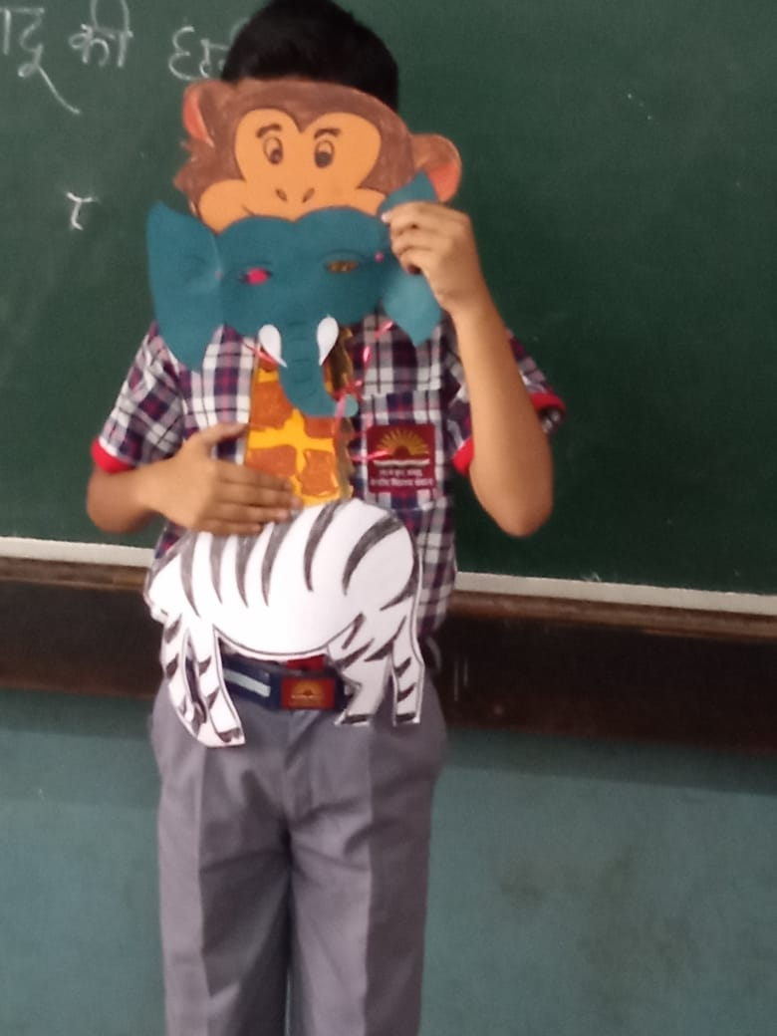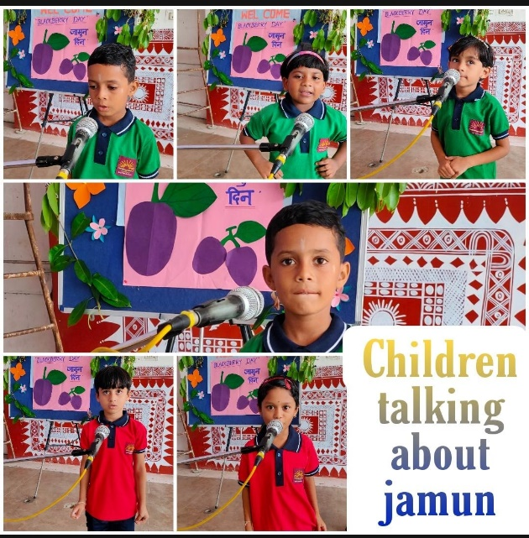
- As per directions of NEP 2020, local language is used as a tool to come to first and second language. Every Saturday a special class of Marathi is organized to make students aware of the Marathi language.
- To achieve the NIPUN BHARAT goal 1- Children maintain good health and wellbeing, students are motivated to bring healthy food. Class teachers take lunch with students which helps them to monitor food quality of students and also develops a bond between teacher and students. Nurse takes regular round and guides students about healthy food.
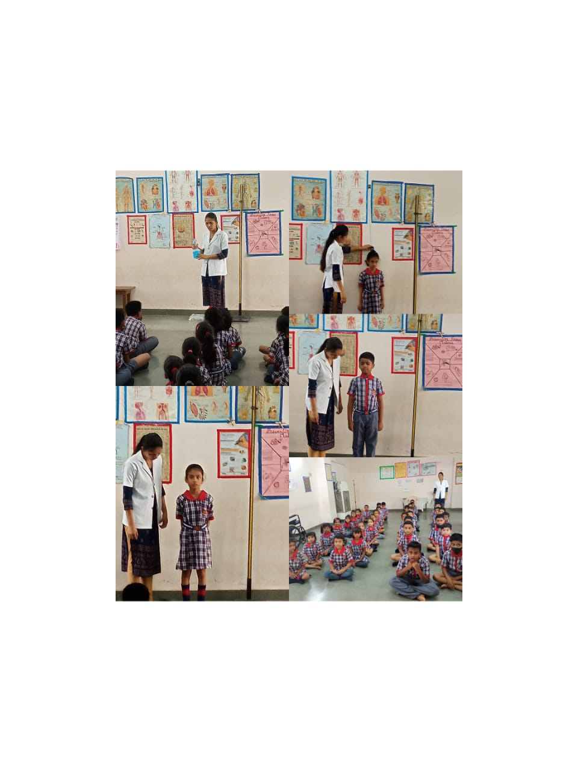

- FLN MELA was conducted in which students had set up the shop and were given opportunity to do purchasing in a dummy market. This helped students to improve their vocabulary in Hindi and English. It also improved their mental Maths.

